Jacob Schmidt

Ryan Sears

Wenquan Lai

Marquise Baggiore

Deposit Campaign

Hello, as you know we have just finished our marketing campaign with the interest of increasing deposits in our long-term savings accounts. We now have access to data that will show us the response to this campaign. From this data, we have learned two important relationships that will allow us to concentrate our attention to two specific factors in raising our amount of deposits.

Figure 1 below shows us the relationship between type of job, age, and whether the client responded with a yes or no to our campaign. From this plot we can see that the most positive response came from retired people over age 50. The yes to no ratio is the largest, and thus we should concentrate our outreach within that demographic. 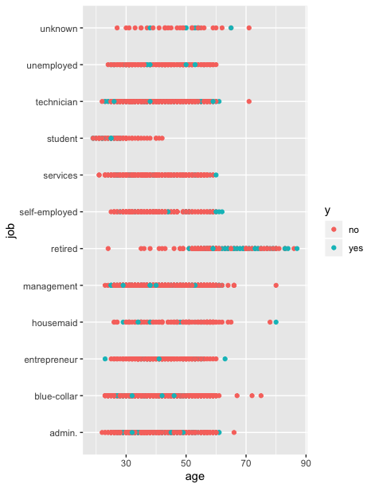

Figure 2 shows us the relationship between marital status, age, and response to our initiative. From this figure we can see that single status demographic responded the weakest, and the married responded the strongest. We should focus our attention on those who are married, or have been divorced.

